Scheduling Scripts and Logs
Introduction
Imagine you have a robot that cleans your house while you are asleep. Since you are sleeping, you can't see the robot working. When you wake up, how do you know if it actually cleaned, or if it got stuck under the sofa?
The answer is: You ask the robot to keep a Diary.
In Linux, automated scripts often run in the background or from schedulers where nobody is watching the terminal. That means screen output is not enough. To keep track of what happened, we write output to a log file instead.
This is one of the simplest but most valuable automation habits. A script without logs can fail silently. A script with logs leaves evidence.
In this lab, you will:
- Divert Output: Teach a script to write to a file instead of the screen.
- Add Integrity: Use the Append operator to add new entries without deleting old ones.
- Add Timestamps: Ensure every diary entry has a date and time.

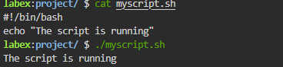

Silence.
The script ran, but it didn't say anything to you. It whispered into the diary instead.
Check the diary:

Append Output to a Log File
Logging is just a practical use of that same mechanism in automation.

> (Overwrite): "Erase the diary and start a new page." (Bad for history)
>> (Append): "Go to the next blank line and write there." (Good for history!)
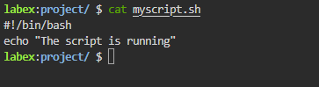

Now we modify the content and try running but nothing happens coz everything is stored in the diary. The modified script is as follows:
#!/bin/bash
echo "The script is running" >> /home/labex/project/script.log
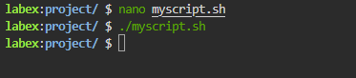
Now we will cat the file and check the content.
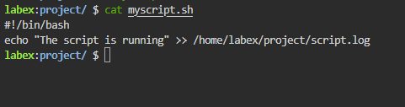
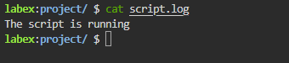

Add Timestamps
We need to add a timestamp. Linux has a command called date that prints the current time. We will redirect that into the log file too.

Open Myscript.sh > Paste the date command > Save and exit > Execute
#!/bin/bash
date >> /home/labex/project/script.log
echo "The script is running" >> /home/labex/project/script.log
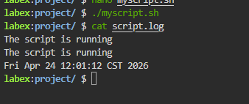
In larger systems, logs also help answer harder questions such as whether a script ran twice, whether it stopped halfway, or how long it took between runs. Good logs turn invisible automation into something you can inspect

Append Output to a Log File
This connects directly to an earlier shell idea: commands normally write to standard output, and redirection changes where that output goes. Logging is just a practical use of that same mechanism in automation.
> (Overwrite): "Erase the diary and start a new page." (Bad for history)
>> (Append): "Go to the next blank line and write there." (Good for history!)

